MATLAB Report

Student ID: 10554466

Contents

Question 1- K-Means Clustering 2

1) 2

2) 2

3) 3

4) 3

a) 4

1) 4

2) 5

3) 6

B) 6

1) 6

2) 6

Question 2 – K Nearest Neighbour Classifier 7

1) 7

2) 7

3) 8

4) 8

5) 9

Data Pre-Processing: 9

KNN Classifier 10

A & B) 10

C) 11

All code for question 1: 12

All Code for question 2: 14

# Question 1- K-Means Clustering

## 1)

Code Used:

rows = size(x,1);

Output:

Rows:

        2028

## 2)

Code Used:

columns = size(x,2);

figure();

for c = 1:columns

temp = x(:,c);

M = mean(temp);

fprintf('Mean of column %d is %d\n',c,M);

sd = std(temp);

fprintf('Standard dev of column %d is %d\n',c,sd);

subplot(2,2,c);

histogram(temp);

title(c);

end

Output:

Mean of column 1 is 9.467046e+00

Standard dev of column 1 is 3.532551e+00

Mean of column 2 is 9.491005e+00

Standard dev of column 2 is 3.511140e+00

Mean of column 3 is 9.514930e+00

Standard dev of column 3 is 3.560468e+00

Mean of column 4 is 9.496788e+00

Standard dev of column 4 is 3.532174e+00

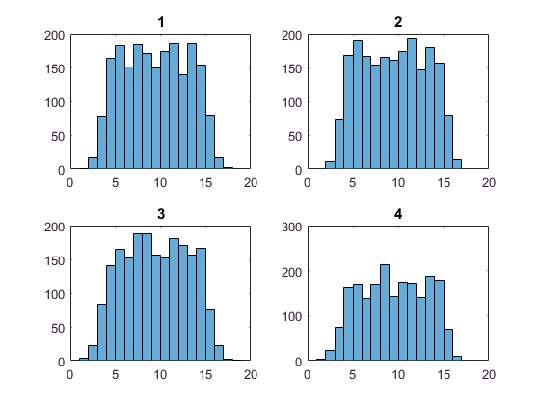

## 3)

Code used:

covarianceMatrix = cov(x);

fprintf('Covariance matrix is ')

disp(covarianceMatrix);

correlationMatrix = corrcov(covarianceMatrix);

fprintf('Correlation matrix is ')

disp(correlationMatrix);

Output:

Covariance matrix is

   12.4789   11.3809   11.4285   11.3998  
   11.3809   12.3281   11.2993   11.3381  
   11.4285   11.2993   12.6769   11.4234  
   11.3998   11.3381   11.4234   12.4763

Correlation matrix is

    1.0000    0.9176    0.9086    0.9136  
    0.9176    1.0000    0.9039    0.9142  
    0.9086    0.9039    1.0000    0.9083  
    0.9136    0.9142    0.9083    1.0000

## 4)

The Mean and Standard deviation show that each feature has similar mean values with similar standard distribution, implying that the data has the same relationships. This is shown in the histogram as you can see each feature appears to be approximately normally distributed. The covariance and Correlation matrixes imply that each of the datapoints is strongly correlated to one another within the given column, implying that the data has similar relationships to each other.

K-means Algorithm

## a)

Code Used:

bestsil = 0;

for k = 3:5

figure();

[idx,C] = kmeans(x,k);

fprintf('co-ordinates of centroids for k = %d are\n',k)

disp(C);

silhouette(x,idx);

meansil = mean(silhouette(x,idx));

if meansil > bestsil

bestsil = meansil;

bestk = k;

bestidx = idx;

bestC = C;

end

fprintf('mean silhouette for k = %d is %d\n',k,meansil);

end;

fprintf('best clustering is %d\n', bestk);

Output:

### 1)

co-ordinates of centroids for k = 3 are

    9.7585    9.8132    9.7884    9.7910  
   13.8104   13.7975   13.8639   13.8161  
    5.5075    5.5252    5.5723    5.5538

co-ordinates of centroids for k = 4 are

    7.9145    7.9195    8.0114    8.0365  
   13.9926   13.9677   14.0073   13.9914  
    4.9724    5.0415    4.9748    4.9239  
   10.9234   10.9696   11.0012   10.9712

co-ordinates of centroids for k = 5 are

    4.9708    5.0392    4.9718    4.9191  
   14.3017   14.4530   14.6446   14.2328  
   10.8931   10.9463   10.9851   10.9435  
    7.9103    7.9162    8.0083    8.0351  
   13.5598   13.3058   13.1431   13.6380

### 2)

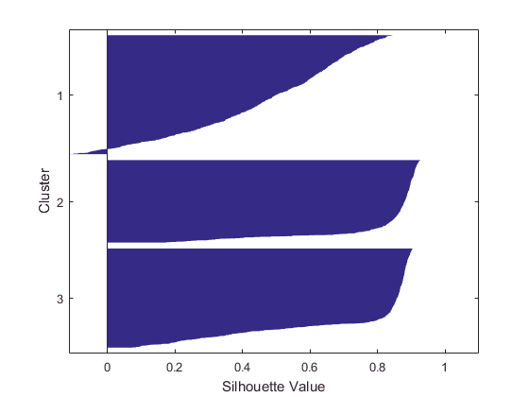

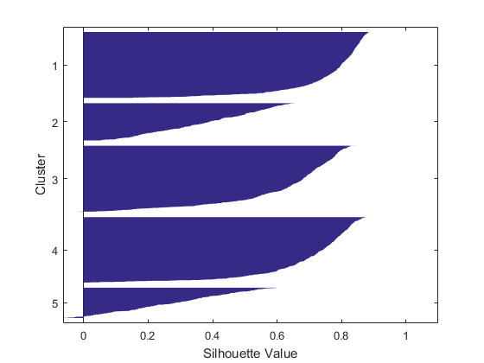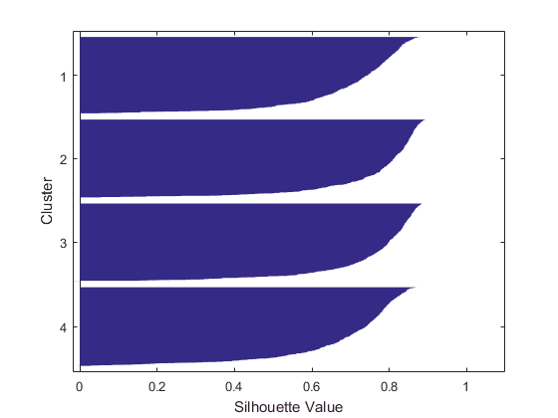

### 3)

mean silhouette for k = 3 is 6.559021e-01

mean silhouette for k = 4 is 7.267338e-01

mean silhouette for k = 5 is 6.001589e-01

## B)

### 1)

Optimal K is 4 as when k=4 mean silhouette is biggest

### 2)

Code Used:

figure();

scatter3(bestC(:,1),bestC(:,2),bestC(:,3),200,'black','*');

hold on;

for j = 1:bestk;

tempScat = ones(1,4);

for i = 1:size(bestidx);

if bestidx(i) == j

tempScat = cat(1,tempScat,x(i,:));

end

end;

scatter3(tempScat(:,1),tempScat(:,2),tempScat(:,3),tempScat(:,4),'filled');

end;

Output:

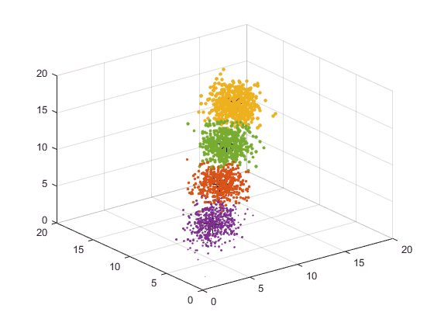

Each colour is a cluster, centroids are Black ‘*’

# Question 2 – K Nearest Neighbour Classifier

## 1)

Code Used:

rows = size(Y,1);

fprintf('rows');

disp(rows);

Output:

rows

3042

## 2)

Code Used:

columns = size(Y,2);

for c = 1:columns-1

temp = Y(:,c);

M = mean(temp);

fprintf('Mean of column %d is %f\n',c,M);

sd = std(temp);

fprintf('standard dev of column %d is %f\n',c,sd);

end

Output:

Mean of column 1 is 8.912831

standard dev of column 1 is 3.049497

Mean of column 2 is 8.922234

standard dev of column 2 is 3.012221

Mean of column 3 is 8.939463

standard dev of column 3 is 3.064609

Mean of column 4 is 8.865053

standard dev of column 4 is 3.055271

Mean of column 5 is 8.886396

standard dev of column 5 is 3.029849

## 3)

Code Used:

covarianceMatrix = cov(Y);

fprintf('Covariance matrix is ')

disp(covarianceMatrix);

correlationMatrix = corrcov(covarianceMatrix);

fprintf('Correlation matrix is ')

disp(correlationMatrix);

Output:

Covariance matrix is

9.2994 7.9629 8.4358 7.9619 8.0060 4.7930

7.9629 9.0735 7.9454 8.0113 7.8904 4.7249

8.4358 7.9454 9.3918 8.0275 8.0326 4.8046

7.9619 8.0113 8.0275 9.3347 8.0075 4.7906

8.0060 7.8904 8.0326 8.0075 9.1800 4.7847

4.7930 4.7249 4.8046 4.7906 4.7847 2.9176

Correlation matrix is

1.0000 0.8669 0.9027 0.8545 0.8665 0.9202

0.8669 1.0000 0.8607 0.8705 0.8646 0.9183

0.9027 0.8607 1.0000 0.8573 0.8651 0.9178

0.8545 0.8705 0.8573 1.0000 0.8650 0.9180

0.8665 0.8646 0.8651 0.8650 1.0000 0.9245

0.9202 0.9183 0.9178 0.9180 0.9245 1.0000

## 4)

Code Used:

NoC = max(Y(:,6));

fprintf('Number of classes is %i\n',NoC);

Output:

Number of classes is 6

## 5)

The mean and Standard deviation of each feature is very similar implying that the dataset consists of similar features, This is further supported by the covariance and correlation matrixes as these imply that there is a strong correlation between the dataset.

## Data Pre-Processing:

Code Used:

%get 60% value

ltr = round(rows*0.6);

%get 40% value

lte = rows - ltr;

%make sure there is less training then total

assert(ltr < rows);

%randomly sort array

rRows = randperm(rows);

%preallocate for efficiency

TrainingSet = zeros(ltr,columns);

TestingSet = zeros(lte,columns);

%fill training set with first 60

for i=1:rows

if i <= ltr

TrainingSet(i,:) = Y(rRows(i),:);

else

TestingSet((i-ltr),:)= Y(rRows(i),:);

end

end

## KNN Classifier

### A & B)

Code Used

k=5;

for a=1:2

fitknn = fitcknn(TrainingSet(:,1:5),TrainingSet(:,6),'NumNeighbors',k);

for i=1:size(TestingSet(:,1:5),1)

Pred_KNN(i) = predict(fitknn,TestingSet(i,1:5));

end

%confusion matrix

for i=1:NoC %max of this is number of classes

in1=find(TestingSet(:,6)==i);

nor=length(in1); %number of datas classified as in1

for j=1:NoC

Classification=length(find(Pred_KNN(in1)==j));

Con_Matrix(j,i)=Classification/nor*100;

end

end

%percentage correct

percentCorrect = length(find((Pred_KNN-TestingSet(:,6)')==0))/length(TestingSet(:,5))*100;

fprintf('For k = %d \n',k);

fprintf('Confusion Matrix\n');

disp(Con_Matrix);

fprintf('Percentage Correct\n');

disp(percentCorrect)

k= k + 2;

End

Output

For k = 5

Confusion Matrix

86.1244 8.9552 0 0 0 0

13.3971 79.6020 10.7623 0.5464 0 0

0.4785 11.4428 77.5785 10.9290 0 0

0 0 11.6592 79.2350 11.3861 0

0 0 0 9.2896 86.6337 3.5176

0 0 0 0 1.9802 96.4824

Percentage Correct

84.2235

For k = 7

Confusion Matrix

88.9952 8.4577 0 0 0 0

10.5263 81.0945 9.8655 0.5464 0 0

0.4785 10.4478 78.0269 11.4754 0 0

0 0 12.1076 81.4208 10.8911 0

0 0 0 6.5574 87.1287 3.5176

0 0 0 0 1.9802 96.4824

Percentage Correct

85.4560

### C)

When K=5 The KNN classifier is 84.2235% correct, When K=7 the KNN classifier is 85.4560% Correct, giving the conclusion that when k=7 The classifier is correct 1.3% more of the time implying that in this case K=7 is better.

# All code for question 1:

clear all;

close all;

%data analysis

x = gen_kmeansdata(10554466);

rows = size(x,1);

disp('Rows: ')

disp(rows);

columns = size(x,2);

figure();

for c = 1:columns

temp = x(:,c);

M = mean(temp);

fprintf('Mean of column %d is %d\n',c,M);

sd = std(temp);

fprintf('standard dev of column %d is %d\n',c,sd);

subplot(2,2,c);

histogram(temp);

title(c);

end

covarianceMatrix = cov(x);

fprintf('Covariance matrix is ')

disp(covarianceMatrix);

correlationMatrix = corrcov(covarianceMatrix);

fprintf('Correlation matrix is ')

disp(correlationMatrix);

%kmeans stuff

bestsil = 0;

for k = 3:5

figure();

[idx,C] = kmeans(x,k);

fprintf('co-ordinates of centroids for k = %d are\n',k)

disp(C);

silhouette(x,idx);

meansil = mean(silhouette(x,idx));

if meansil > bestsil

bestsil = meansil;

bestk = k;

bestidx = idx;

bestC = C;

end

fprintf('mean silhouette for k = %d is %d\n',k,meansil);

end;

fprintf('best clustering is %d\n', bestk);

%scatter best clustering

figure();

scatter3(bestC(:,1),bestC(:,2),bestC(:,3),200,'black','*');

hold on;

for j = 1:bestk;

tempScat = ones(1,4);

for i = 1:size(bestidx);

if bestidx(i) == j

tempScat = cat(1,tempScat,x(i,:));

end

end;

scatter3(tempScat(:,1),tempScat(:,2),tempScat(:,3),tempScat(:,4),'filled');

end;

# All Code for question 2:

clear all;

close all;

rng shuffle;

Y = gen_superdata(10554466);

rows = size(Y,1);

fprintf('rows');

disp(rows);

columns = size(Y,2);

for c = 1:columns-1

temp = Y(:,c);

M = mean(temp);

fprintf('Mean of column %d is %f\n',c,M);

sd = std(temp);

fprintf('standard dev of column %d is %f\n',c,sd);

end

NoC = max(Y(:,6));

fprintf('Number of classes is %i\n',NoC);

covarianceMatrix = cov(Y);

fprintf('Covariance matrix is ')

disp(covarianceMatrix);

correlationMatrix = corrcov(covarianceMatrix);

fprintf('Correlation matrix is ')

disp(correlationMatrix);

%get 60% value

ltr = round(rows*0.6);

%get 40% value

lte = rows - ltr;

%make sure there is less training then total

assert(ltr < rows);

%randomly sort array

rRows = randperm(rows);

%preallocate for efficiency

TrainingSet = zeros(ltr,columns);

TestingSet = zeros(lte,columns);

%fill training set with first 60

for i=1:rows

if i <= ltr

TrainingSet(i,:) = Y(rRows(i),:);

else

TestingSet((i-ltr),:)= Y(rRows(i),:);

end

end

k=5;

for a=1:2

fitknn = fitcknn(TrainingSet(:,1:5),TrainingSet(:,6),'NumNeighbors',k);

for i=1:size(TestingSet(:,1:5),1)

Pred_KNN(i) = predict(fitknn,TestingSet(i,1:5));

end

%confusion matrix

for i=1:NoC %max of this is number of classes

in1=find(TestingSet(:,6)==i);

nor=length(in1); %number of datas classified as in1

for j=1:NoC

Classification=length(find(Pred_KNN(in1)==j));

Con_Matrix(j,i)=Classification/nor*100;

end

end

%percentage correct

percentCorrect = length(find((Pred_KNN-TestingSet(:,6)')==0))/length(TestingSet(:,5))*100;

fprintf('For k = %d',k);

fprintf('Confusion Matrix');

disp(Con_Matrix);

fprintf('Percentage Correct');

disp(percentCorrect)

k= k + 2;

end